**UI/UX Evaluation**

**Common Issue throughout the software**

1. **Login Authentication Method – Replit OAuth Integration:**

**Observation:** Login is handled via single-step OAuth through Replit, requesting basic profile and email access.

**Impact:** Single-factor authentication is insufficient for applications handling sensitive audit data, increasing security risks.

**Accessibility Standard:** Does not meet industry standards (e.g., NIST, OWASP) which recommend multi-factor authentication for secure access.

**Recommendation:**

* Retain current Replit OAuth as Step 1.
* Add Step 2 with **Two-Factor Authentication (2FA)**:
* Use **Authenticator Apps** (Google Authenticator, Microsoft Authenticator, Authy) to generate TOTP codes.
* Provide fallback via email or SMS OTP.
* Optionally allow trusted device recognition for 30 days.

**Benefit:**

* Enhances data protection and access control.
* Aligns with enterprise-grade security standards.

1. **Contrast of Secondary and Instructional Text:**

**Observation:** Secondary or instructional text (e.g., “Click to view audits/risks/findings/actions” and similar helper messages) often appears with low contrast against the background.

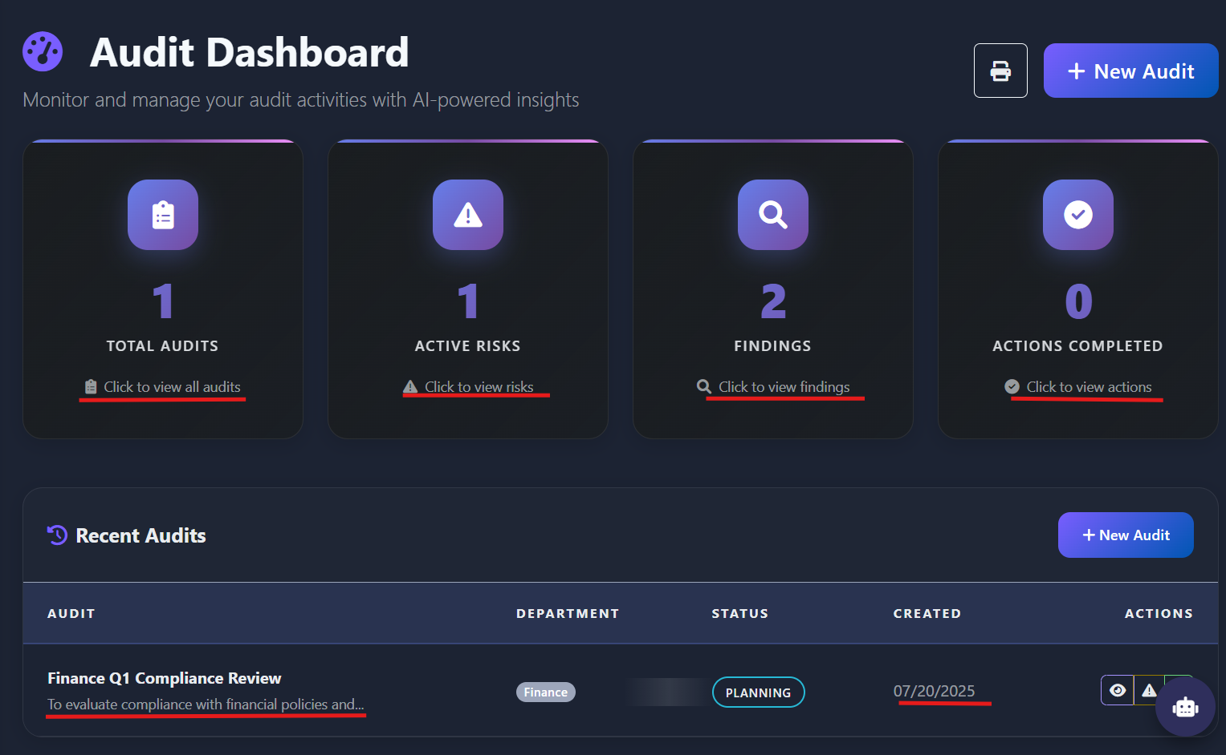

**Impact:** This low contrast makes such text difficult to read, particularly for users with visual impairments or when viewed in low-light environments.

**Accessibility Standard:** According to the Web Content Accessibility Guidelines (WCAG), all text should maintain a minimum contrast ratio of 4.5:1 against its background to ensure readability and compliance.

**Recommendation:** Instead of increasing the contrast when hovered over the component, increase the contrast of all secondary and instructional text throughout the application. Use colour pairings that meet or exceed WCAG standards, ensuring that these messages are easily readable for all users.

**Benefit:** Enhancing text contrast will significantly improve accessibility, user experience, and inclusivity across the application.

**Some other examples of similar pattern observed on other screens**:

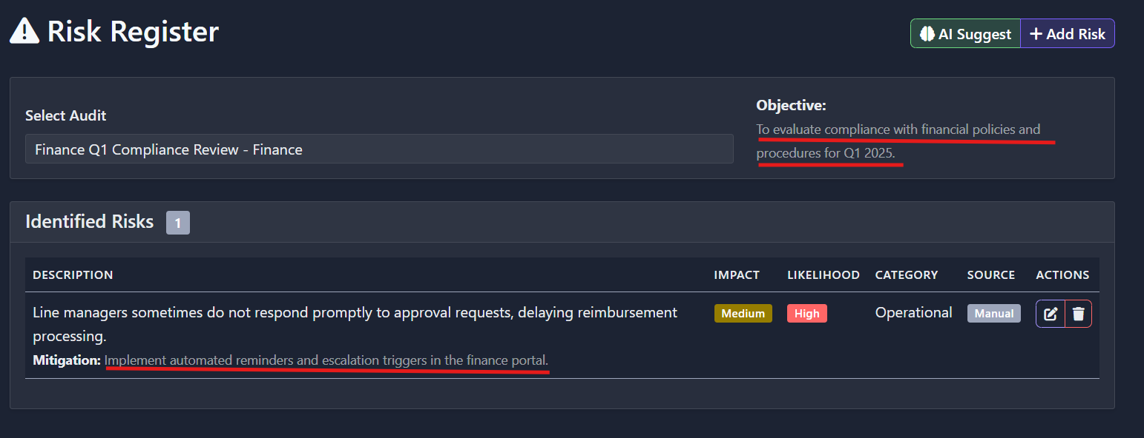

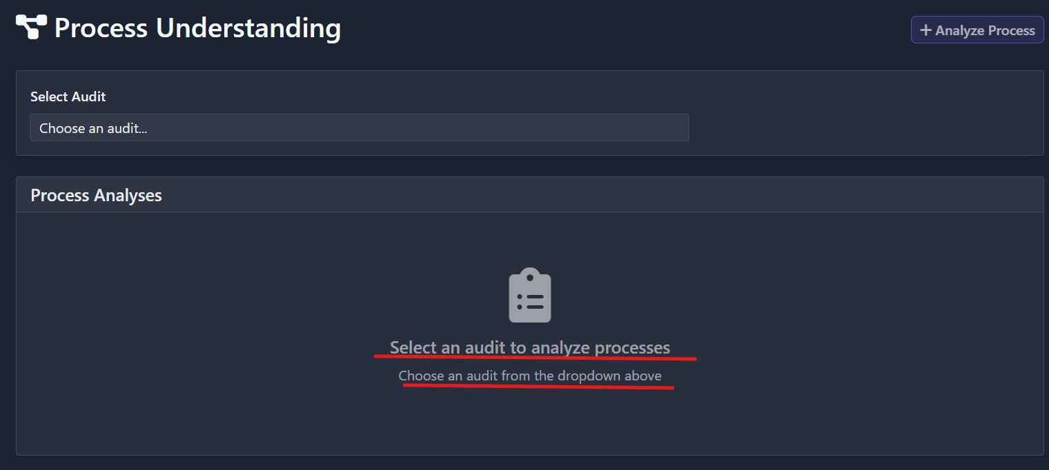

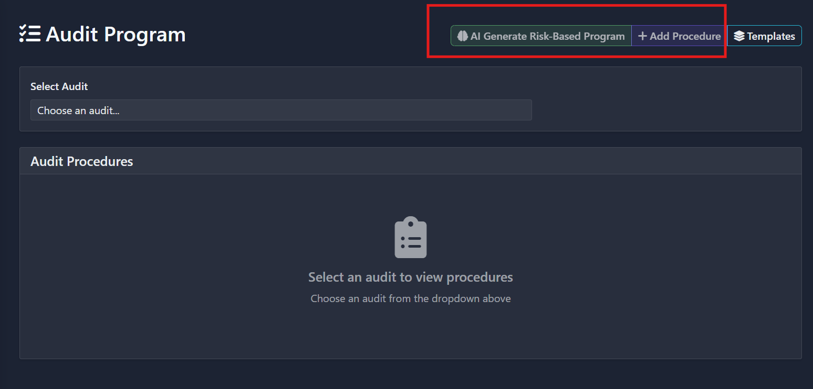

1. **Accessibility Issue – Poor Contrast in Dropdown Options:**

**Observation:** Across multiple modules (as shown in the Process Understanding and Risk Register screens), the dropdown options display low text contrast against a white or light background. This makes it difficult for users to clearly distinguish and read the available selections — especially on lower-brightness screens or in low-light environments.

**Example Screens:**

* + - **Department selection** dropdown in the Create new audit.
    - **Select Audit** dropdowns in the Process Understanding.
    - **Category** inadd audit procedure and so on.

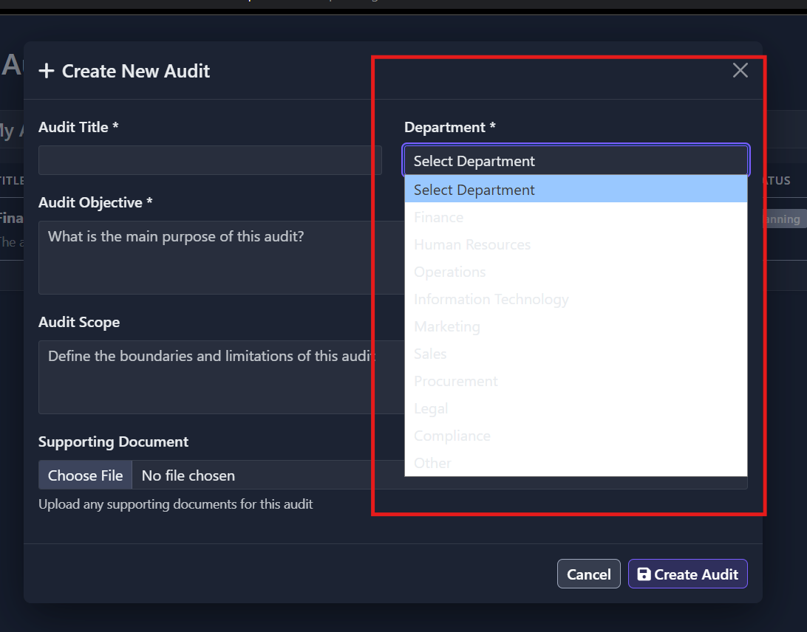 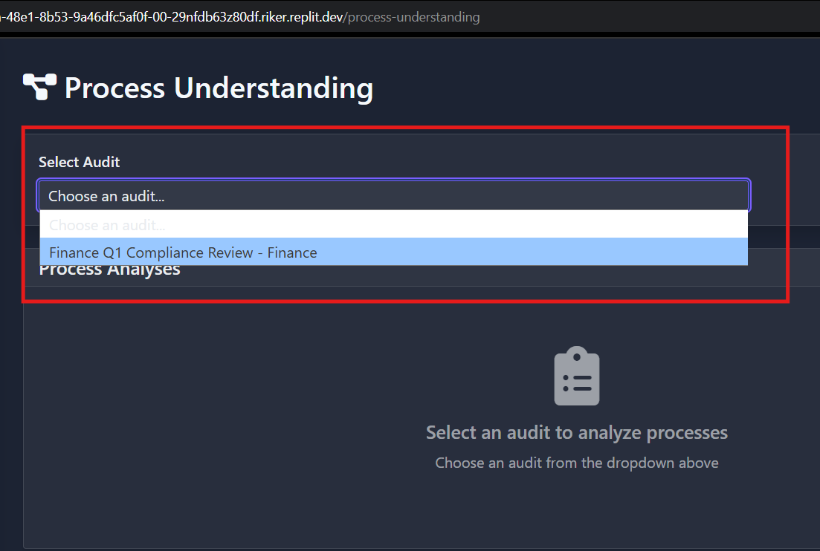

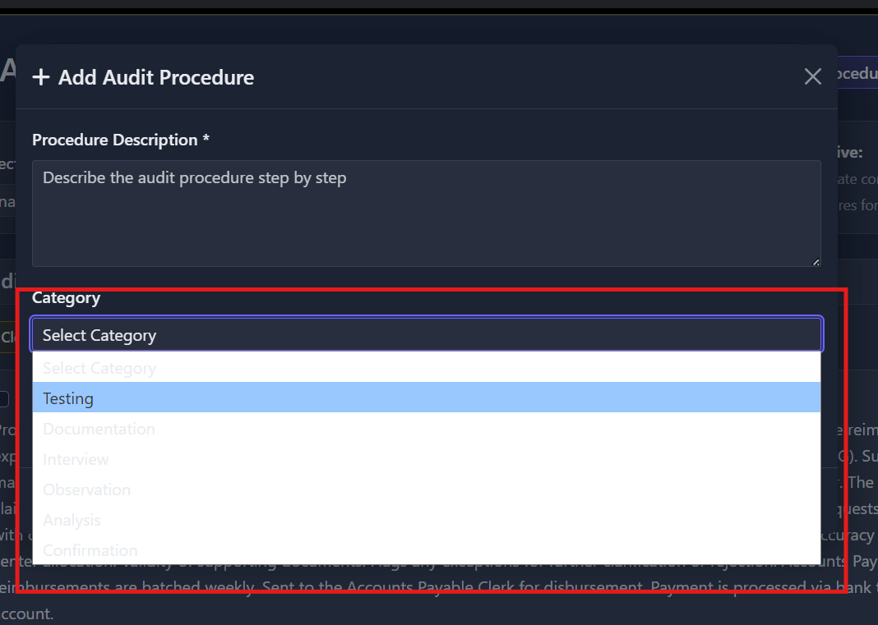

**Impact:** This low contrast makes such text difficult to read, particularly for users with visual impairments or when viewed in low-light environments.

**Accessibility Standard:** According to the Web Content Accessibility Guidelines (WCAG), all text should maintain a minimum contrast ratio of 4.5:1 against its background to ensure readability and compliance.

**Recommendation:** Increase the contrast of all secondary and instructional text throughout the application. Use colour pairings that meet or exceed WCAG standards, ensuring that these messages are easily readable for all users.

**Benefit:** Enhancing text contrast will significantly improve accessibility, user experience, and inclusivity across the application.

**Some other examples of similar pattern observed on other screens**

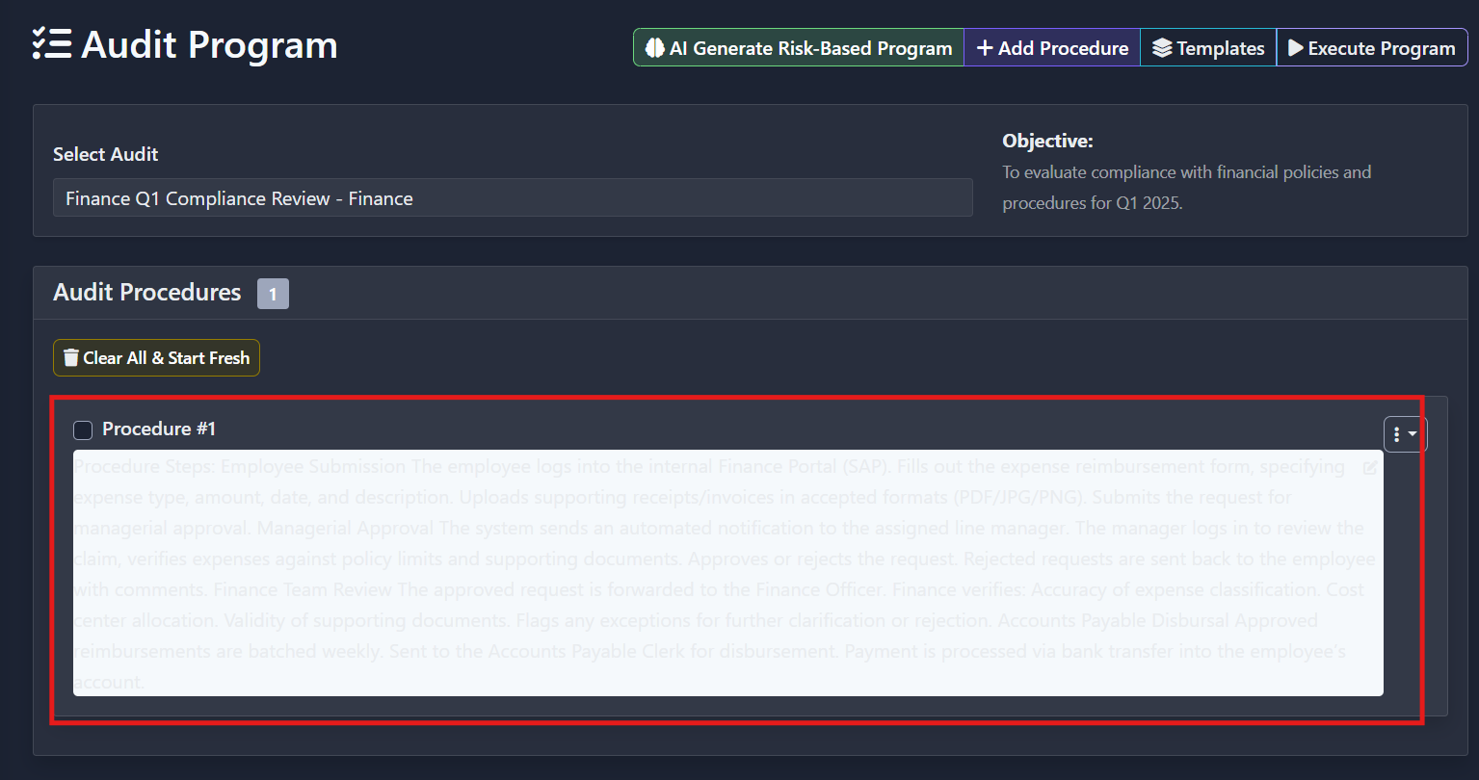

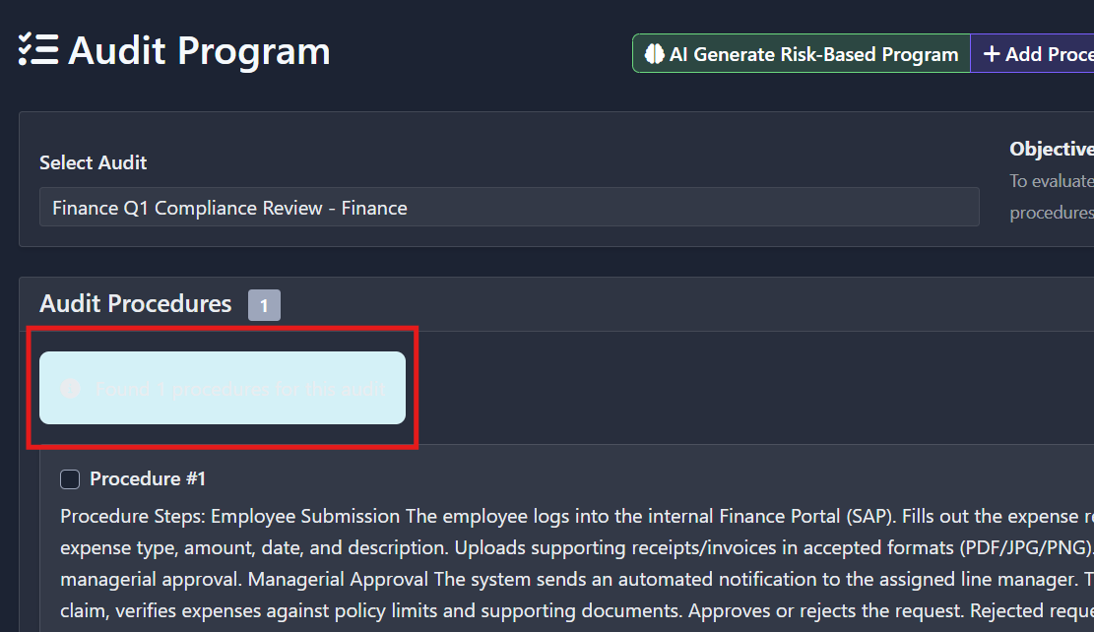

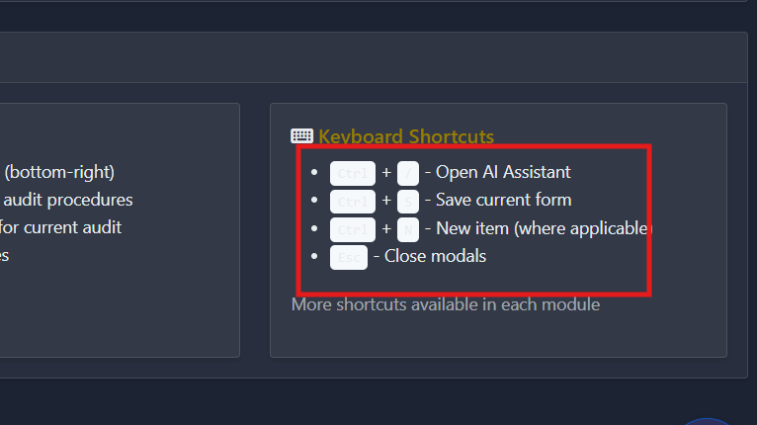

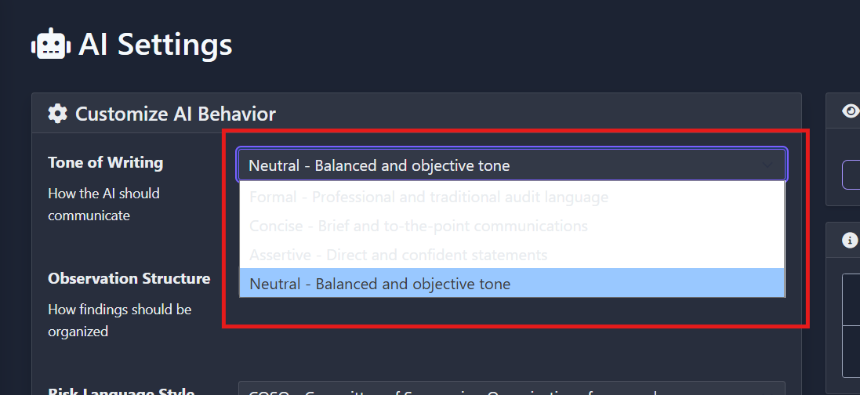

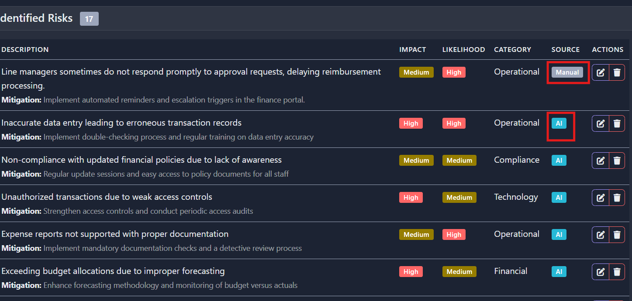

1. **Misaligned “Select Audit” and “Objective” Headings:**

**Observation: Observation:**  
Throughout multiple modules in the application (e.g., **Audit Program**, **Process Understanding**, **Risk Register**), the **“Select Audit”** and **“Objective”** sections are **not properly aligned**. The heading and content blocks often appear **vertically offset**, creating inconsistency in the visual layout

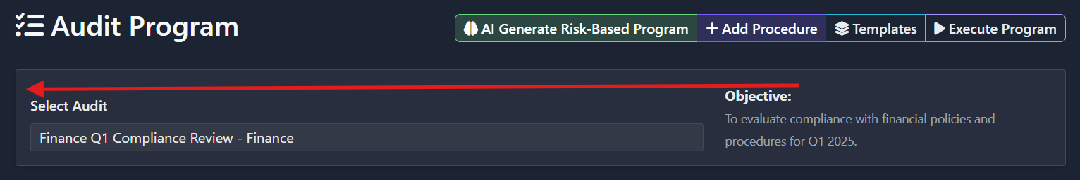

**Impact:** This inconsistency disrupts the **visual hierarchy** and makes the interface look uneven. Misalignment may distract users, reduce trust in the design’s polish, and lead to unnecessary visual scanning.

**Recommendation:** Apply a **consistent layout structure** for these commonly repeated blocks:

* + Align “Select Audit” and “Objective” on the **same horizontal baseline**
  + Use a **shared parent grid or flex container** with standardized spacing and alignment
  + Apply equal **padding and margin** values to all heading blocks and content panels

**Benefit:** Enhancing text contrast will significantly improve accessibility, user experience, and inclusivity across the application

1. **Redundant Buttons:**

**Observation: Observation:**  
On the **Audit Findings** page, when no findings have been recorded yet, two call-to-action buttons are displayed:

A **top-right “+ Add Finding”** button

A **centre-aligned “+ Record First Finding”** button within the empty state prompt

This creates redundancy and causes unnecessary visual distraction during the initial state of user interaction.

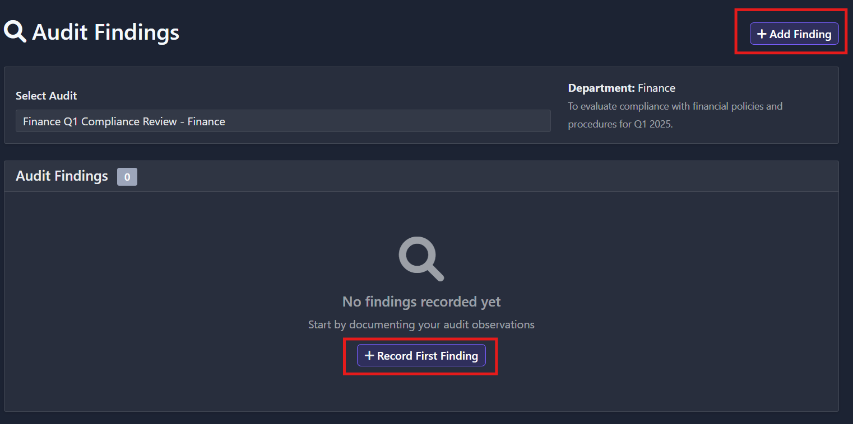

**Impact:**

* + - Having two CTAs for the same action causes UI clutter and breaks visual focus.
    - It may overwhelm or confuse new users by offering multiple options for a single path.
    - This increases **decision fatigue** and weakens the effectiveness of a clearly guided flow, especially during onboarding or first use.

**Recommendation:**

* + - **Hide** the top-right **“+ Add Finding”** button when no findings are present.
    - **Only display** the cantered **“+ Record First Finding”** button in the empty state.
    - Once the first finding has been added, **restore and consistently display** the top-right action button for quick access.

**Benefit:**

* + - **Cleaner visual interface** and reduced distractions
    - Helps users focus on the next immediate step without ambiguity
    - Establishes a guided and consistent user journey, especially for new or non-technical users

**Some other examples of similar pattern observed on other screens**:

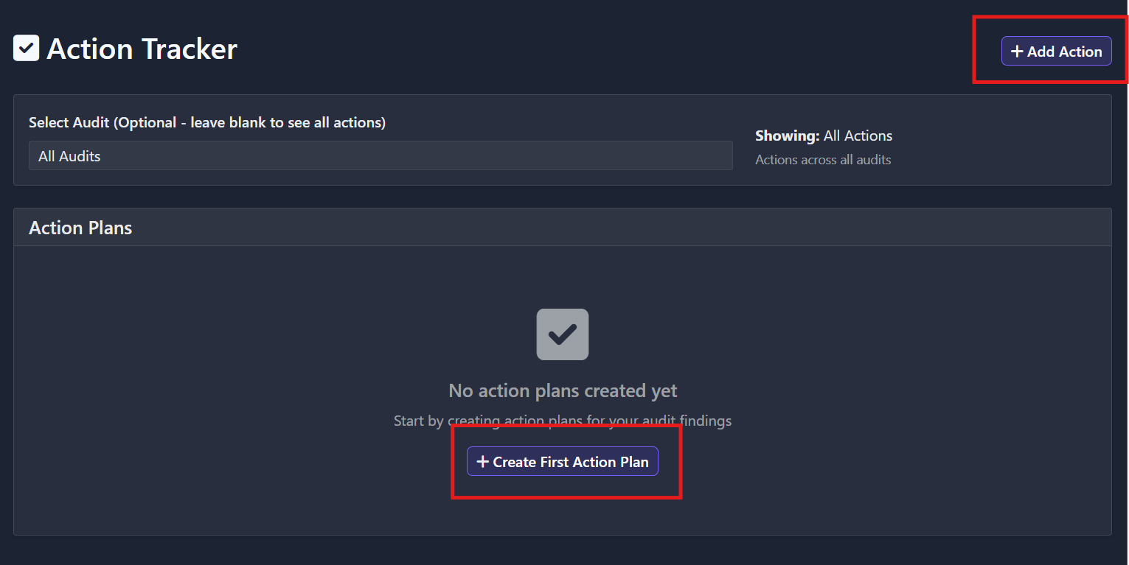

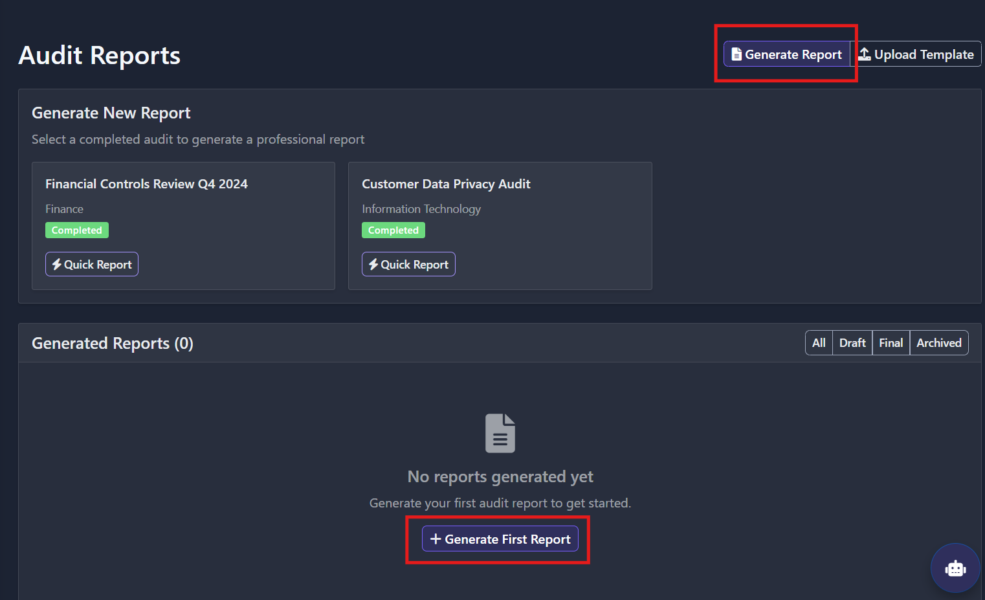

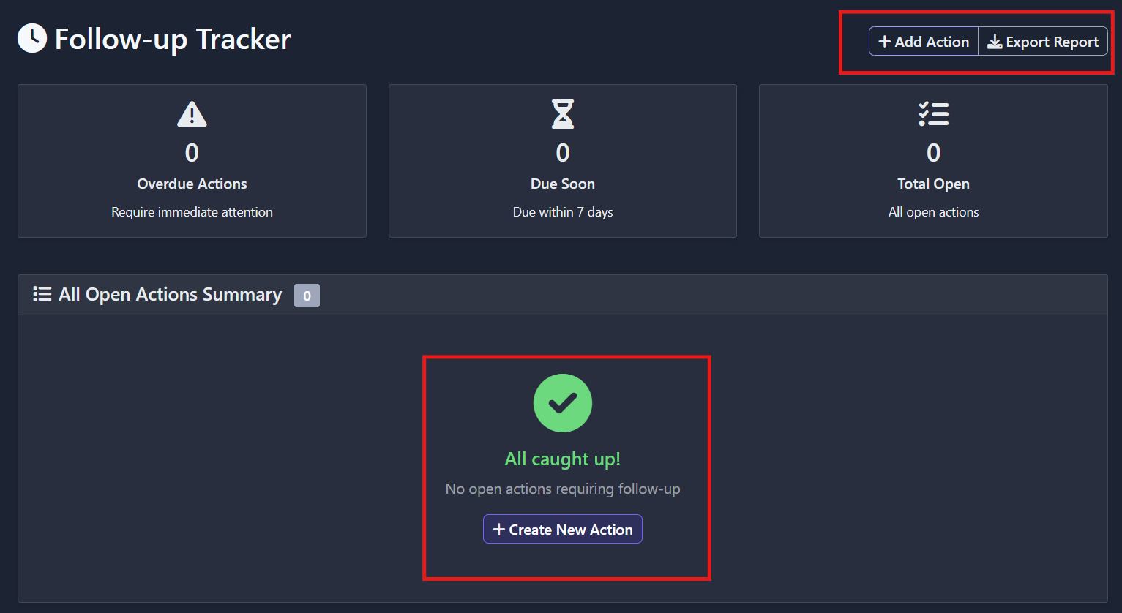

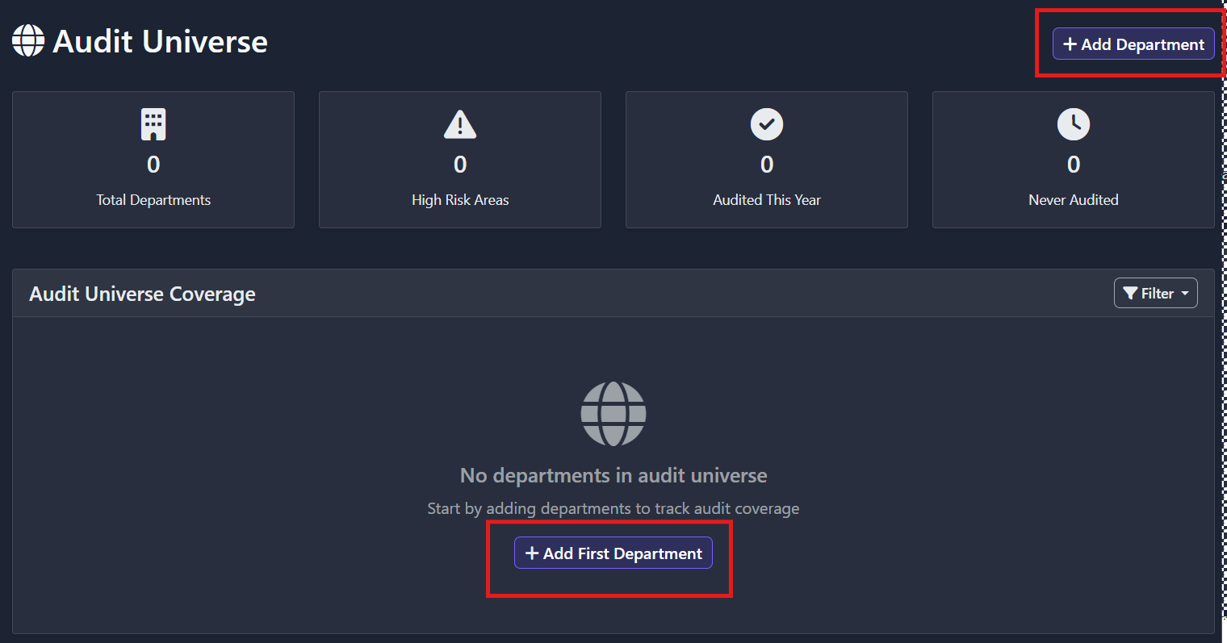

1. **Display of “Analyse Process” Button Without Audit Selection:**

**Observation:** On the **Process Understanding** screen, the **“+ Analyze Process”** button is displayed even when no audit is selected. This can mislead users into thinking they can initiate a process analysis immediately, but the button is either disabled or non-functional, creating confusion.

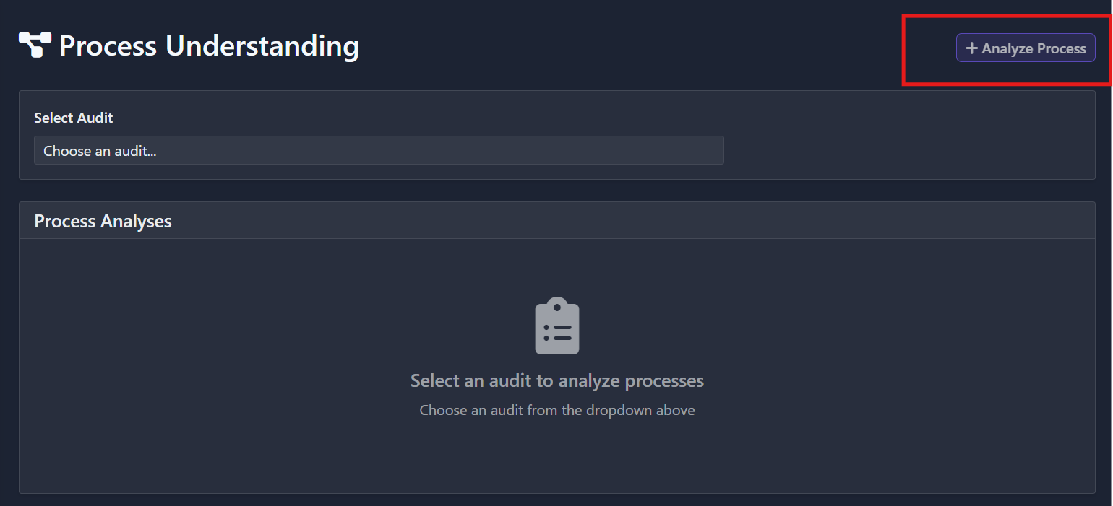

**Impact:** Users may experience a disjointed flow, as they are presented with an action that cannot be executed yet. This disrupts task orientation, especially for first-time users, and may lead to incorrect assumptions about system behaviour.

**Recommendation:** Do not display the “+ Analyse Process” button unless an audit has been selected. Only render the action button once the audit dropdown has a valid selection. Additionally, modify the current instructional helper text from

“Choose an audit to analyse processes”  
to something more intuitive and actionable like  
“Select an audit to start process analysis.”

**Benefit:** Improves interface clarity by showing only contextually relevant actions, reduces confusion, and creates a more guided and intuitive experience. This change also enhances consistency with other parts of the app where action buttons are conditionally rendered based on user input.

**Some other examples of similar pattern observed on other screens**:

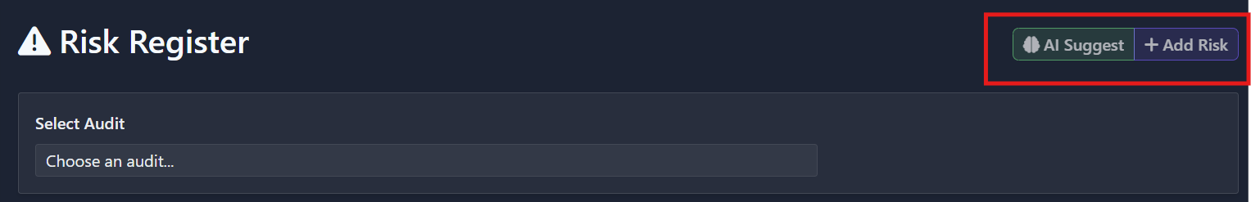

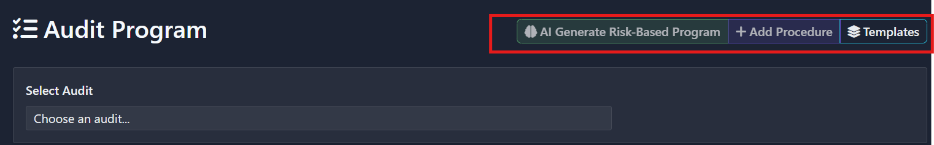



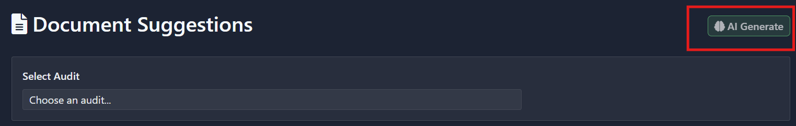

1. **Inconsistent Badge Styling Across Modules:**

**Observation:**  
On the some screens like **Process Understanding** screen, the section labeled "Process Analyses" only becomes populated **after** an audit is selected from the dropdown. This creates a static and empty view for the user upon arrival, with no prior visibility of available processes or historical data. Additionally, the current interaction relies solely on the audit dropdown, offering minimal discoverability or engagement.

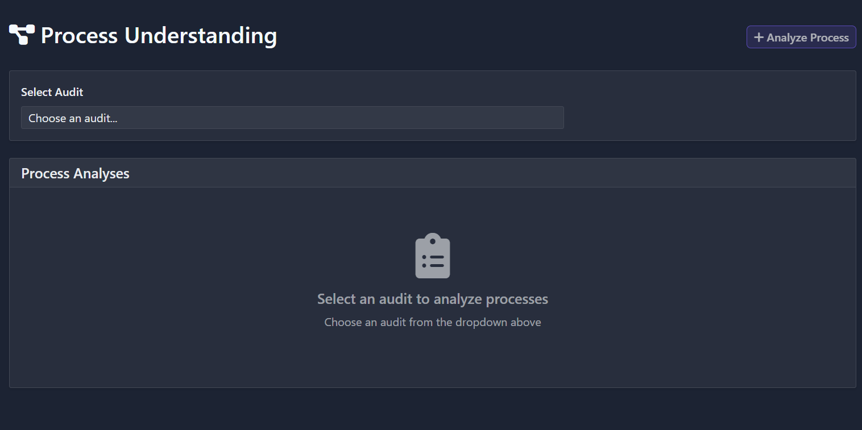

**Impact:**

* Creates a **disconnected user experience**, as users cannot view available process analyses upfront.
* Reduces visibility into **previously saved process plans**, which may be critical for review, comparison, or edits.
* **Misses opportunities for contextual interaction**—e.g., selecting a specific process and jumping directly into planning.
* Makes the screen feel empty and underutilized.

**Recommendation:**

* **Display a list of available process names** under “Process Analyses” **by default**, even before selecting an audit.
* When a user clicks on a specific process from the list:
* Allow them to **view existing process planning details** (if any).
* Provide an option to **add/edit planning** directly for that process.
* Repurpose the current **audit selection dropdown** into a **searchable filter bar**, enabling users to **search audits** quickly to narrow the process list.

**Benefit:**

* Encourages exploration and **improves visibility of past work**, enhancing system transparency.
* Provides **quicker access to planning actions**, reducing unnecessary clicks and navigation friction.
* Makes the interface more **interactive and informative** from the beginning, improving first impressions.
* Facilitates a **smoother workflow for auditors** who revisit processes or manage multiple audit engagements simultaneously.

**Some other examples of similar pattern observed on other screens**:

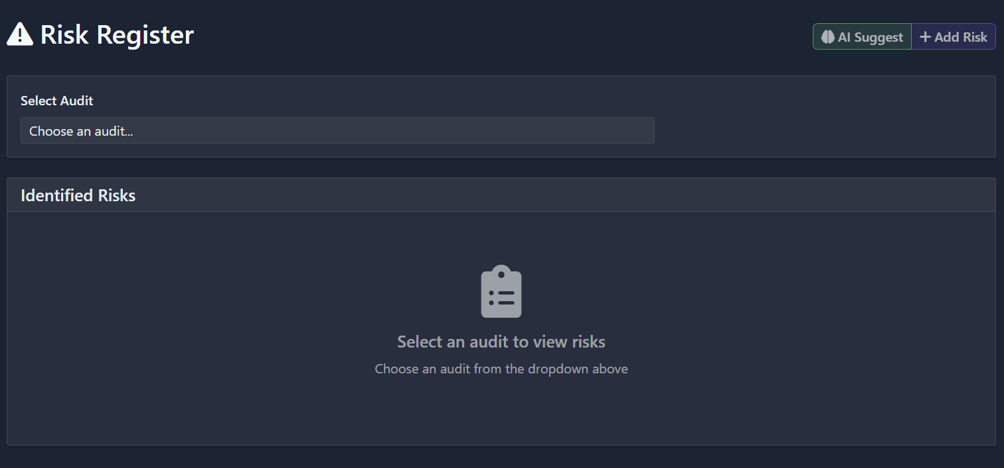

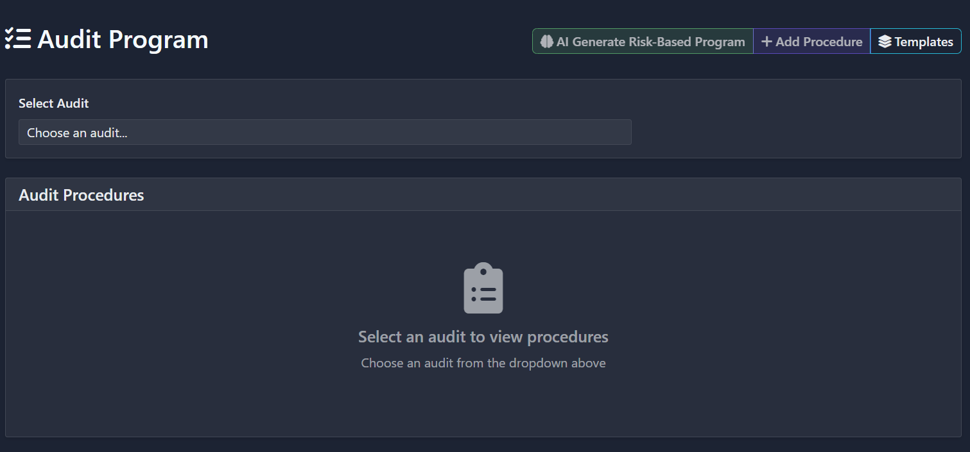

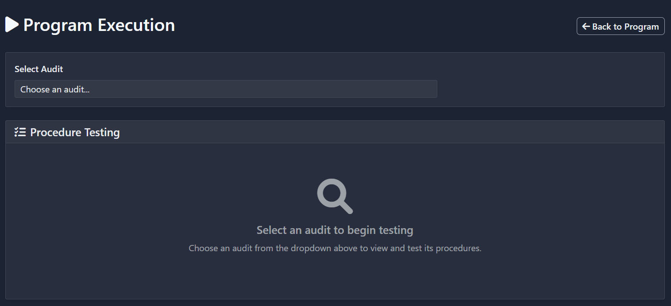

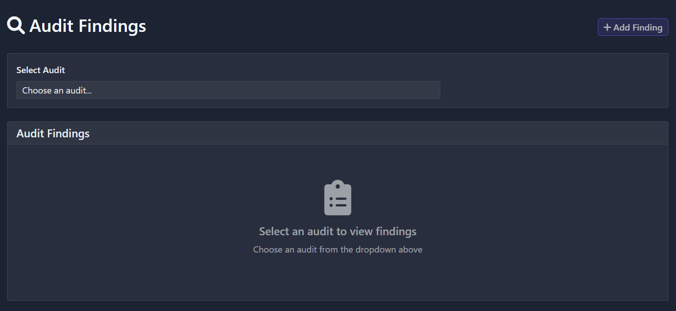

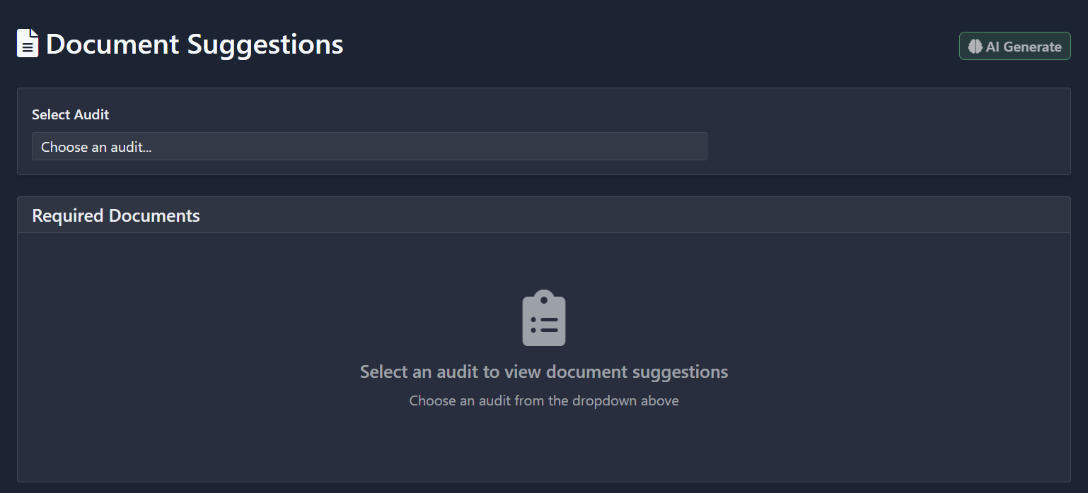

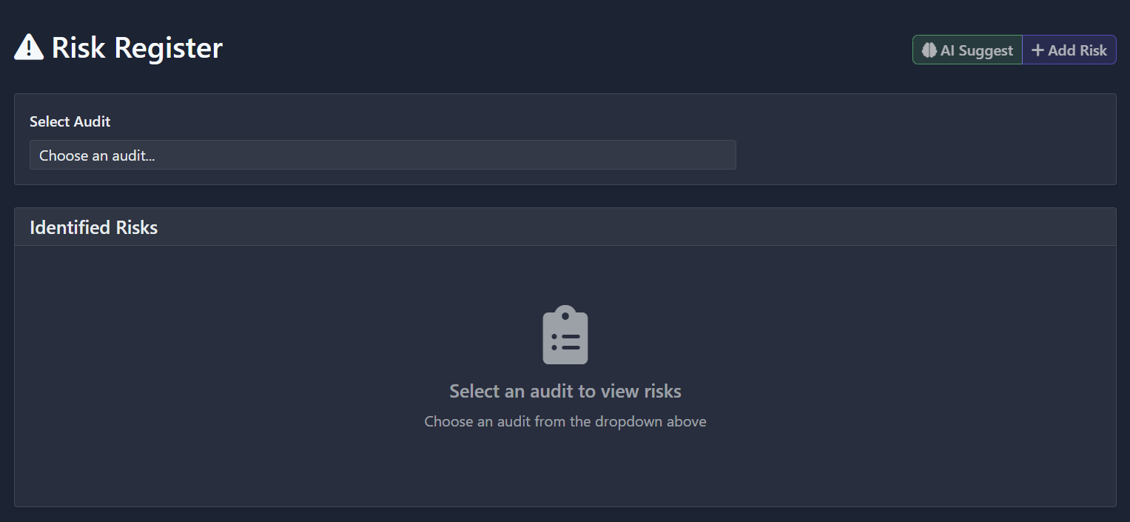

1. **Uses the browser’s native window:**

**Observation:** Your application currently uses the browser’s native window, Confirm dialogs in multiple places. These dialogs follow inconsistent browser styling, interrupt interaction, and feel outdated within your app’s modern UI.

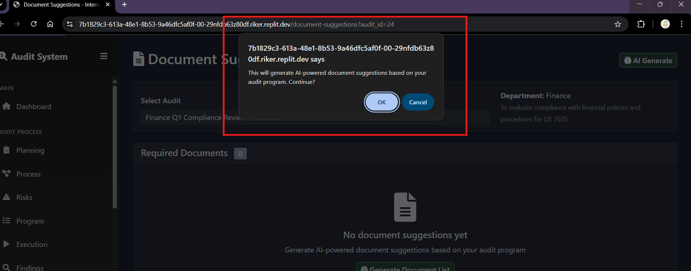

**Impact:** Your application currently uses the browser’s native window.confirm dialogs in multiple places. These dialogs follow inconsistent browser styling, interrupt interaction, and feel outdated within your app’s modern UI.

**Recommendation:**

* Implement your own custom modal dialog for confirmations.
* Style it for visual coherence with your app: use matching fonts, buttons, branding.
* Call it only on user‑initiated actions requiring confirmation.

**Benefit:**

* Delivers a smoother, more predictable user experience aligned with your design system.
* Enhances clarity with custom messaging and context-specific confirmations (“Generate Document Suggestions?”).
* Improves accessibility and consistency across platforms, boosting both usability and professional perception.

1. **“Actions” and “Follow-up” Buttons Not Functioning:**

**Observation:**  
In the left sidebar under the **"MANAGEMENT"** section, the **“Actions”** and **“Follow-up”** buttons appear styled and clickable, but do not trigger any visible response or screen transition.

**Impact:**

* Users may assume the app is broken or incomplete.
* Creates a dead-end in navigation, blocking task workflows related to action tracking and follow-ups.
* Undermines user trust in the system’s functionality and completeness.**Recommendation:**

**Recommendation:**

* Ensure that both buttons are **wired to active routes or modals**. If the corresponding features are under development, use a disabled state with a tooltip such as “Coming soon”.
* Visually indicate that the buttons are inactive (e.g., reduced opacity, disabled cursor).
* Log UI events or interactions to console/network to verify if it’s a frontend or backend disconnect

**UI/UX Evaluation**

**Dashboard Screen**

* **Strengths:**
  + The dark theme is modern and visually appealing, with good use of accent colours for key metrics.
  + Dashboard cards (Total Audits, Active Risks, Findings, Actions Completed) are well-spaced, visually distinct, and use clear icons.
  + The sidebar navigation is logically grouped (Main, Audit Process, Management), aiding discoverability.
  + The “New Audit” button is prominent and easily accessible.
  + User profile and email are clearly displayed at the bottom left, supporting user orientation.
* **Areas for Improvement:**
  + **Button/Badge Inconsistency**: In the Recent Audits row, the “Finance” badge is styled as a pill-shaped button, while the “PLANNING” status is a rounded rectangle. The visual language is inconsistent—use a unified badge style for both.

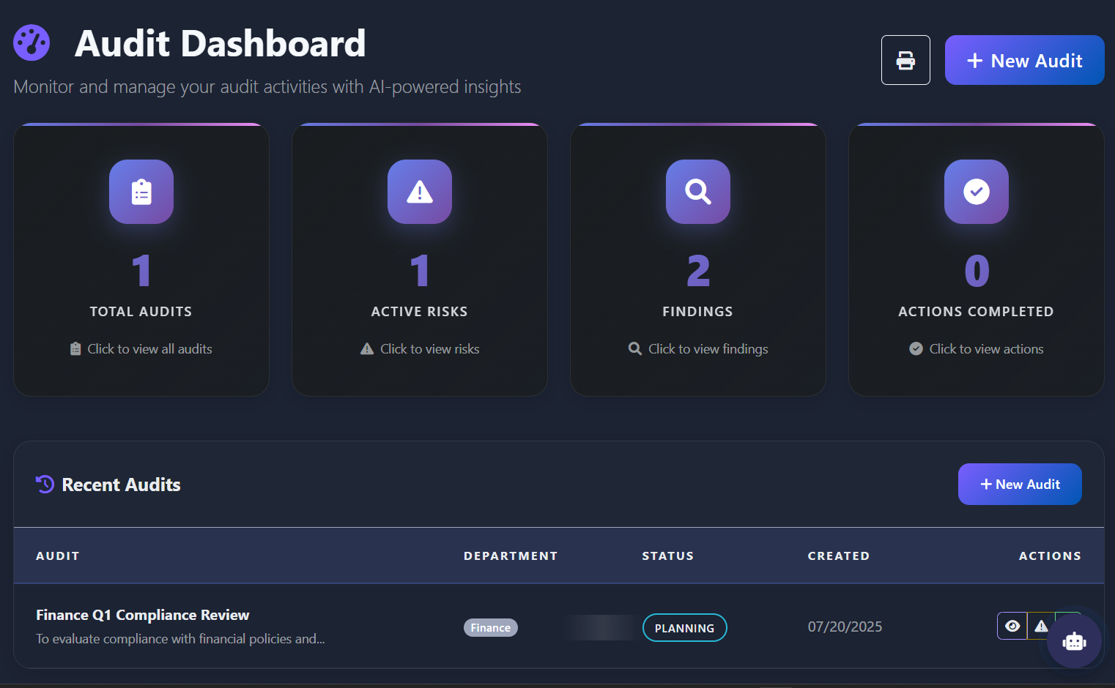

* **AI Icon Alignment:** Properly align the AI robot icon within the AI Insights card.

* **Docking and Alignment of Action Status Cards:** The action status cards (“Overdue”, “Open”, “Completed”, “Total”) are currently positioned lower within their container, leaving a large empty space above them.
  + Why this is a problem:

Wasted Space: The large gap above the cards reduces the efficiency of the dashboard layout, especially on smaller screens or when users need to scroll.

Dock Content to Top: Align the action status cards to the top of their container, minimizing unnecessary vertical space.

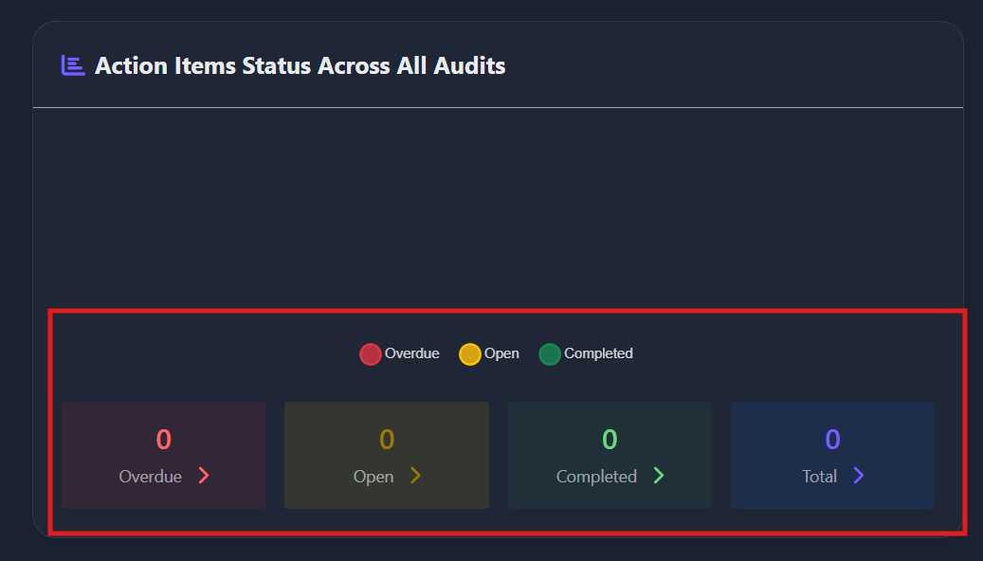

* **Focus Indicators – Accessibility Enhancement:** Add visible focus states (such as outlines, glows, or colour changes) for all interactive elements (buttons, links, cards, form fields, icons, etc.).
  + **Why it matters: Keyboard Navigation:** Many users—including those with motor impairments, temporary injuries, or power users—navigate web applications using the keyboard (Tab, Shift Tab, Enter, Space, Arrow keys) instead of a mouse. Visible focus indicators show which element is currently selected, making navigation clear and efficient.
  + **Screen Reader Users:** Focus indicators help users who rely on screen readers to understand where they are in the interface, especially when moving between interactive elements.
  + **Cognitive Accessibility:** Clear focus states reduce confusion and cognitive load, helping users with attention or memory challenges keep track of their actions.
  + **Legal & Standards Compliance:** WCAG (Web Content Accessibility Guidelines) require visible focus indicators for all interactive elements to meet AA/AAA accessibility standards. This is also a legal requirement in many regions (e.g., ADA, Section 508).

**UI/UX Evaluation**

**Audit Planning Screen**

* **Areas for Improvement:**

1. **Inconsistent Badge Styling Across Modules:**

**Observation:**  
On various pages such as the **Audit Planning**, **Audit Dashboard**, and **Audit Program**, the **badges for department (e.g., “Finance”)** and **audit status (e.g., “Planning”)** are rendered with **inconsistent styling**—including variations in font size, padding, border radius, background color, and alignment.

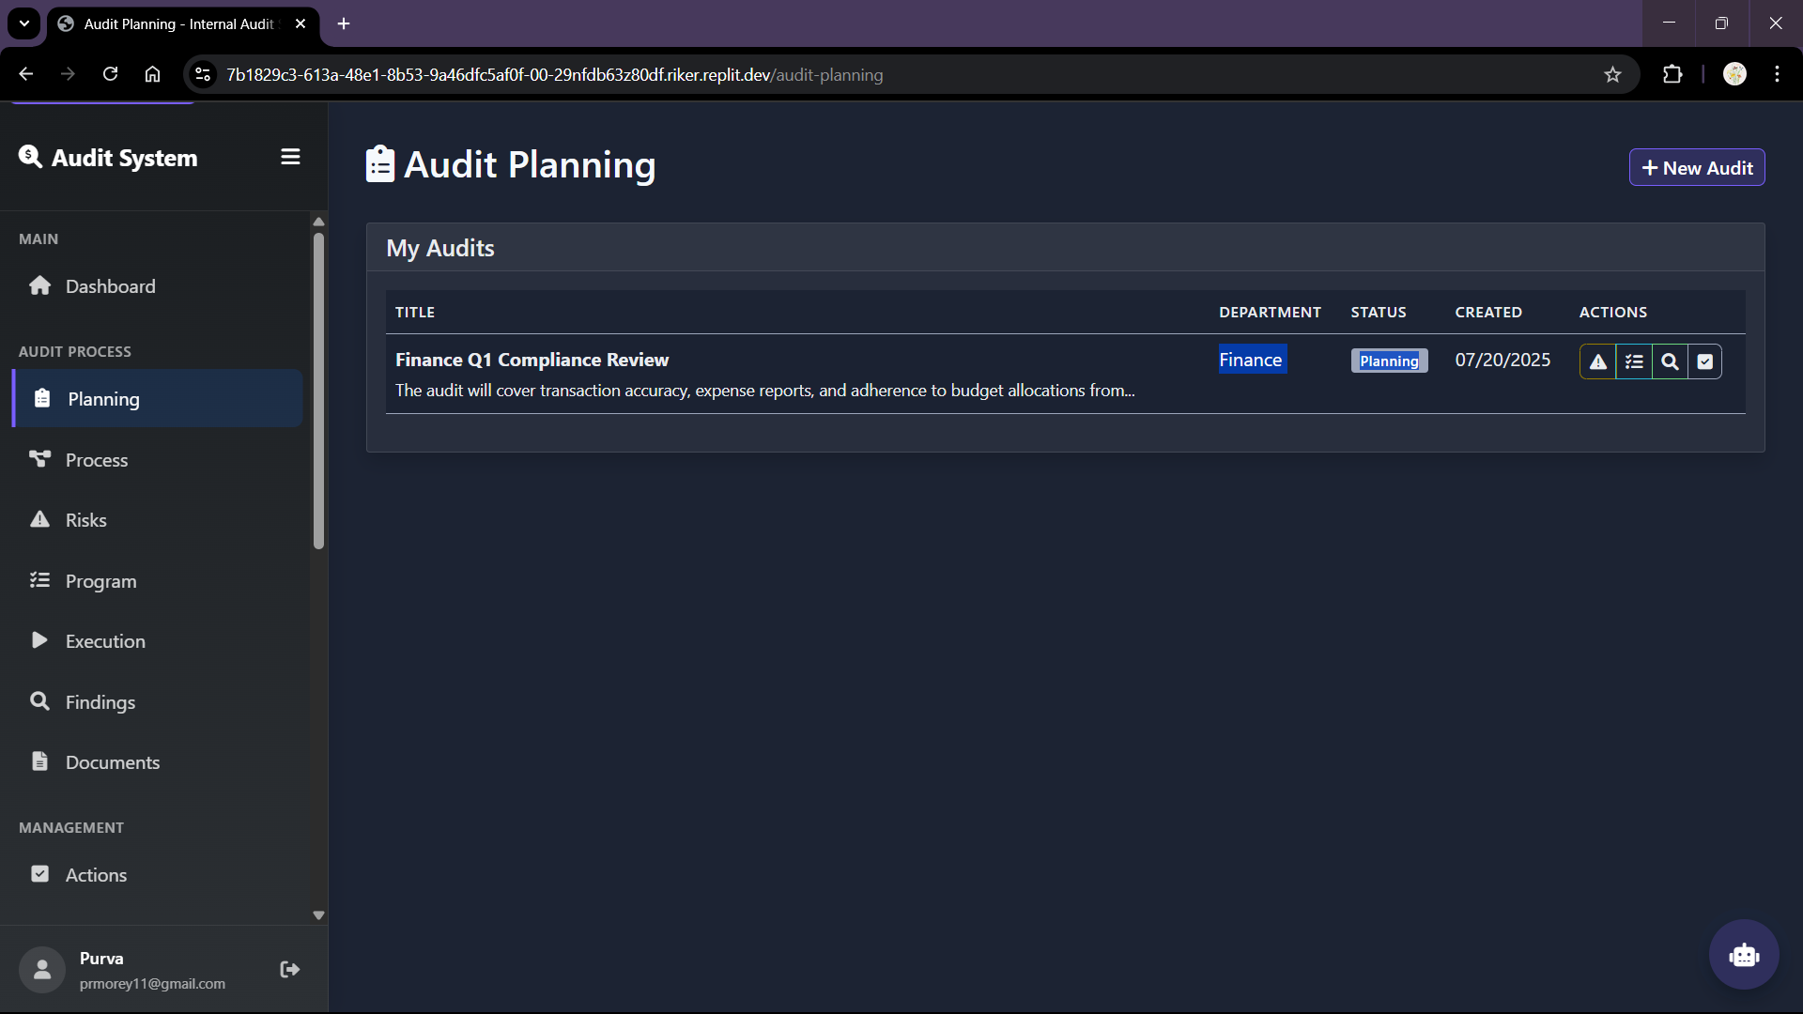

**Impact:**

* Creates **visual fragmentation**, weakening the UI’s overall coherence.
* Users may **not associate similar elements** across pages due to inconsistent visual language.
* Reduces the **recognizability** of key metadata indicators (like status or department), which are meant to guide user attention quickly.

**Recommendation:**

* + Establish and enforce a **unified badge component** in the design system for all status and department indicators.

**Benefit:**

* Creates a **cohesive visual identity** across the application
* Improves **usability and recognition** of metadata for quicker decision-making

1. **Unlabelled Action Icons in Audit Planning Table**:

**Observation:**  
Within the **“Audit Planning”** module, under the **“Actions”** column of the audit table, only icon-based buttons are used to represent core functionalities:

* + (View Risks)
  + (View Program)
  + (View Findings)
  + (View Actions)

These icons are not accompanied by any text labels. This forces users to guess the function of each icon, especially for first-time users or those unfamiliar with icon semantics.

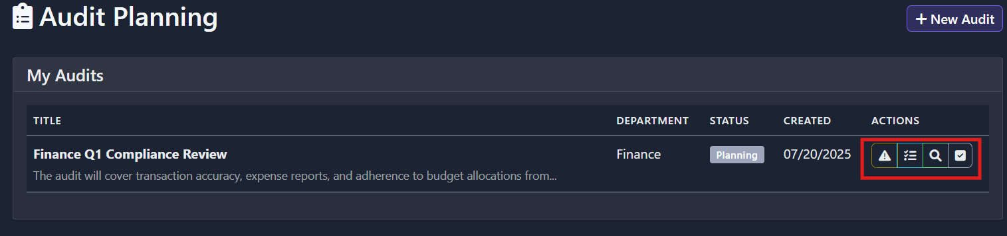

**Impact:**

* Reduces **usability and discoverability** of key actions.
* Creates **cognitive load** and confusion, especially for non-technical users or individuals with visual/cognitive impairments.
* Violates accessibility and usability heuristics, which recommend using **clear affordances and descriptive labels**.
* Difficult to maintain consistency and clarity across different modules using similar icon-only actions.

**Recommendation:**  
Replace the cluster of unlabelled icons with a **single, clearly labelled “Actions” button**. On click, this button should open a **dropdown or popover menu** with the following labelled options:

* + View Risks
  + View Program
  + View Findings
  + View Actions

**Benefit:**

* Enhances clarity and guides the user through the available options more intuitively.
* Makes the interface **more accessible, especially for users with disabilities**.

**UI/UX Evaluation**

**Process Understanding Screen**

**Areas for Improvement:**

* + - 1. **Unlabelled Action Icons in Audit Planning Table**:

**Observation:**  
The “AI Generated Risks” list currently presents a static list of items (e.g., Risk 1, Risk 2) without any sorting or filtering controls based on severity (impact), likelihood, or department—making it time-consuming to locate or prioritize specific items.



**Impact:**

* Users must manually scan the full list, increasing time and reducing efficiency, especially in large audits.
* Lacks quick prioritization based on severity or relevance—hurting decision-making and risk triage.
* Can lead to oversight of critical risks and lower audit quality.

**Recommendation:**

Add a toolbar above the list with:

* Sorting dropdown (Impact desc/asc, Likelihood desc/asc, Department A‑Z/Z‑A)
* Filter controls: checkboxes or multi-select for Impact, Likelihood, Department.
* Implement dynamic table updates: list re-renders in real-time as users sort or filter.
* Optionally allow saving custom views or presets for later reuse.

**Benefit:**

* Speeds up identification of high-priority risks.
* Supports role-based filtering (e.g., dept heads view their own risks).
* Improves usability, reduces cognitive load by presenting only relevant data, and aligns with enterprise filter/sort best practices

**UI/UX Evaluation**

**Risk Register Screen**

* + - 1. **Colour Intensity**:

**Observation:**  
The current green and purple used in the UI (e.g. for Likelihood tags and highlights) are highly saturated and bright. On a dark-themed interface, these colours stand out too strongly and disrupt visual harmony.

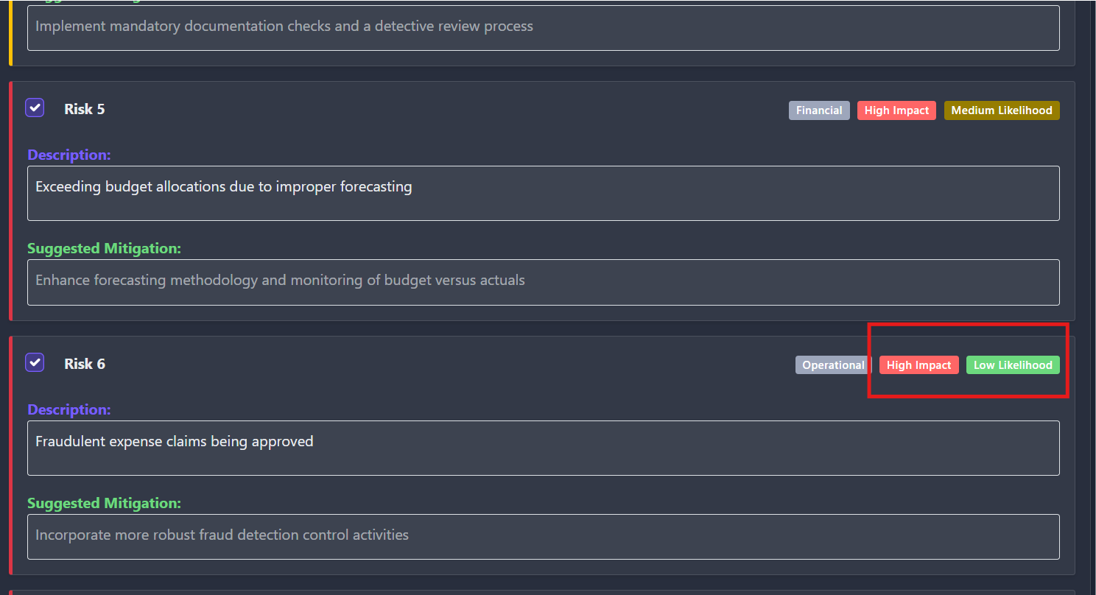

**Impact:**

* They inadvertently draw attention away from critical elements such as high-impact indicators or content.
* They create a visual tension and may cause strain during extended use.
* They conflict with established dark-mode design principles, which favour muted or desaturated accent tones to maintain balance and depth.

**Recommendation:**

Keep tone consistent with the dark UI palette by opting for desaturated, low‑chroma shades rather than bright hues. This aligns with best practices from dark-mode design, where gentle accents and minimal colour usage help preserve readability and visual hierarchy.

**Benefit:**

* Maintains a sleek, professional aesthetic that feels cohesive rather than jarring
* Enhances focus on priority items (like red high-impact tags) without unwanted colour competition
* Reduces visual fatigue and supports better accessibility across the board

**2.Remove Hover Highlight on Subheading Text**:

**Observation:**  
The "Objective" subheading text currently responds to mouse hover by highlighting (changes color or background). However, this subheading is entirely non-interactive and serves no clickable function.

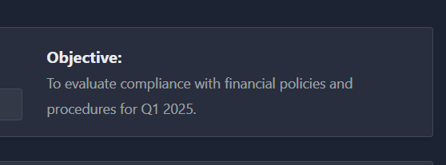 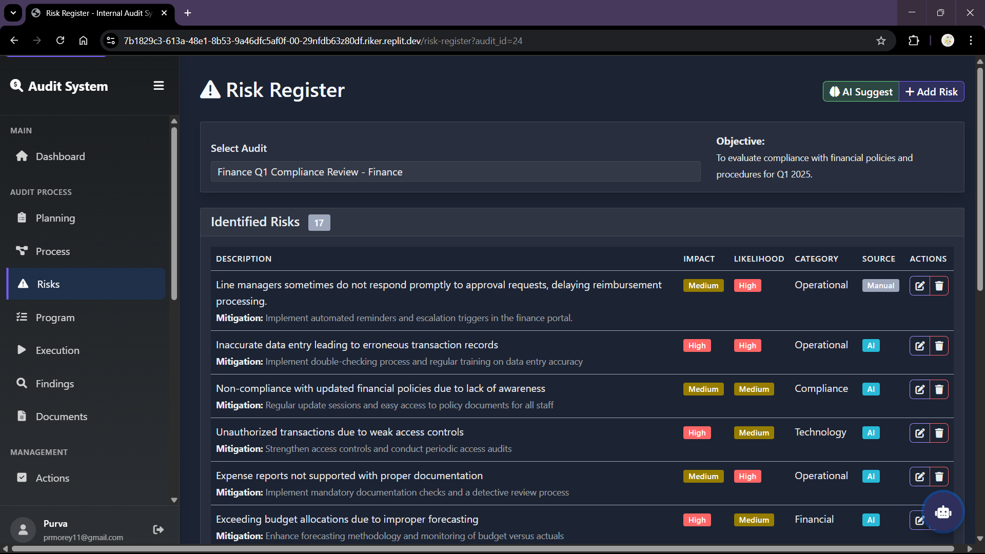

**Impact:**

* Misleading to users—hover effects suggest actionable elements, creating false affordances.
* Triggers unnecessary visual feedback that offers no value and may confuse first-time or non-technical users.

**Recommendation:**

* **Remove hover styling** from all non-interactive static text, including the subheading.
* Reserve hover effects exclusively for interactive UI elements (e.g., links, buttons, cards with clickable actions).
* Preserve keyboard focus styling separately on actual interactive components for accessibility, but avoid styling focus/hover on static text

**Benefit:**

* Eliminates misleading cues and aligns visual behavior with intent, improving user comprehension.
* Reduces unnecessary visual noise and preserves consistency.
* Enhances usability and accessibility by adhering to recognized interaction design standards

**UI/UX Evaluation**

**Audit Program Screen**

* + - 1. **“Templates” Button: Not working**:

**Observation:**  
The “Templates” button is visually enabled but entirely unresponsive when clicked—users expect it to function but nothing happens..

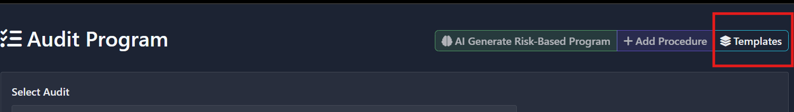

**Impact:**

* Generates user frustration and undermines trust in the interface.
* Interrupts workflow, potentially leading users to abandon tasks or assume the product is broken.

**Recommendation:**

* If feature is not yet available, **disable** it with lowered opacity, a "not-allowed" cursor, and an explanatory tooltip (e.g., “Coming Soon”).
* If functionality exists but fails, either **fix the click behavior** or **remove the button** until stable.

**Benefit:**

* Aligns with best practices: disabled buttons must clearly signal inactivity, or else remain hidden if irrelevant

**UI/UX Evaluation**

**Execution Screen**

* 1. **Improving Contrast for “Procedure Test Status Updated to Pass” Notification**:

**Observation:**  
The success notification banner is too faint and blends into the dark background, reducing its visibility and making it easy to overlook.

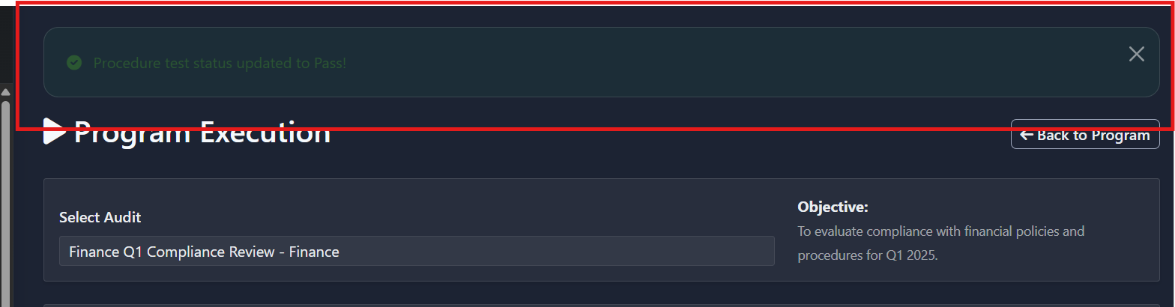

**Impact:**

* Users may **miss critical feedback**, unaware that their action succeeded.
* Poor visibility undermines **confidence** and may prompt unnecessary re-clicking.

**Recommendation:**

* Use a stronger green background (e.g., desaturated emerald) that achieves ≥ 3:1 contrast ratio against the dark UI.
* Apply white or off-white text with at least 4.5:1 contrast relative to the green.
* Enhance readability with subtle padding, rounded corners, and a drop-shadow or light border to visually lift the banner from the background

**Benefit:**

* Ensures users **immediately notice success feedback**, improving interaction clarity.

**UI/UX Evaluation**

**Findings Screen**

**1.Improving Contrast for**:

**Observation:**  
When users hover over the “Structured Finding” text panel, the background or overlay becomes nearly the same brightness as the text, rendering the content virtually unreadable under hover.

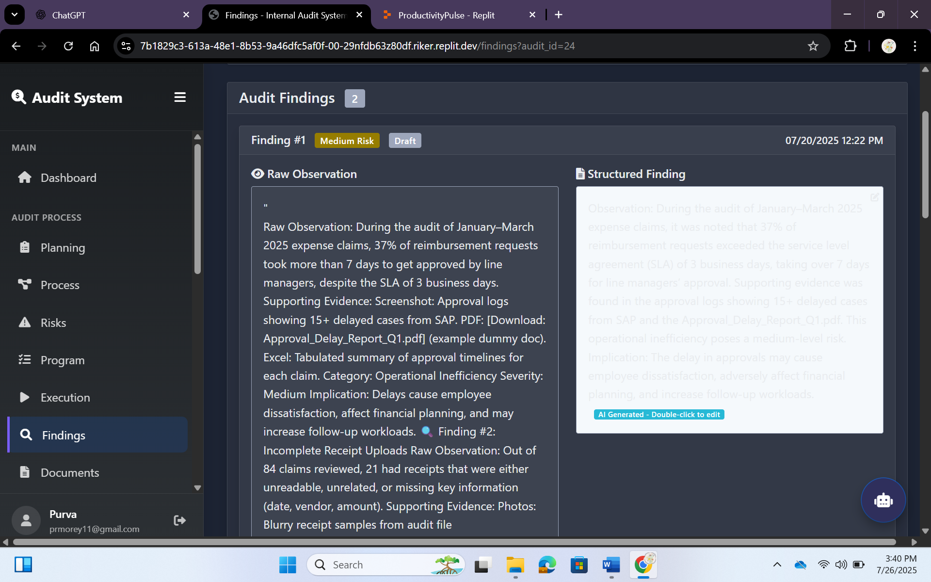

**Impact:**

* Reduces readability for hovered content—making it difficult or impossible to read.
* Creates unexpected visual disruption, interrupting user flow and comprehension.
* Violates accessibility standards—hover states must maintain sufficient contrast to avoid confusion or loss of information.

**Recommendation:**

* WCAG requires a contrast ratio of at least **4.5:1** for normal text and **3:1** for UI components in all interaction states, including hover and focus.
* Adjust the hover background to ensure a clear contrast—lighter or darker than the default hover state—so the **text remains legible at all times**.
* Avoid using hover color changes that reduce distinction; instead, consider **slight elevation**, **border highlight**, or **soft glow** to indicate hover without compromising readability.

**Benefit:**

* • Enhances task awareness and improves efficiency.
* • Aligns with Jakob’s Law—leveraging familiar layouts where users expect progress at the top.

**UI/UX Evaluation**

**Document Suggestions Screen**

* + - 1. **Redundant “Export List” Button**:

**Observation:**  
The “Export List” button is visually available but currently non-functional—clicking it produces no result..

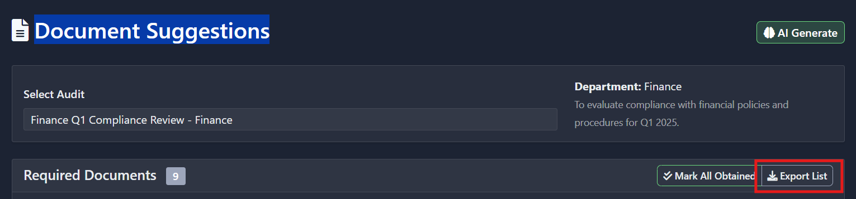

**Recommendation:**

* + **If feature is imminent but not ready:**
* **Disable** the button (reduced opacity + ‘not-allowed’ pointer).
* Add a **tooltip** explaining the status (“Available soon” or “Requires data generation”).
* **If feature will never apply in this context:**
* **Hide** the button completely to avoid unnecessary noise.

**2.** **Keep "Document Collection Progress" Fixed at Page Top**:

**Observation:**  
The progress component (Total, Obtained, Required) currently scrolls off-screen, making users scroll back up to track progress.

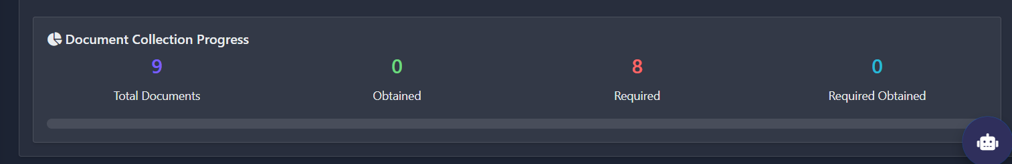

**Impact:**

* Users lose visibility of essential task status while reviewing document fields below.
* Causes wasted effort and disrupts the flow when returning to the top.
* Increases cognitive load as users must remember or recalculate progress.

**Recommendation:**

* Make this component **sticky/fixed** just below the main header or toolbar.

• **Benefit:**

* Improved and consistent readability during hover—ensuring smooth review and editing of Findings.
* Preserves clarity and trust during interactions, improving overall user experience.

**3. “Mark All Obtained” Button Inconsistent Selection:**

**Observation:**  
Clicking **Mark All Obtained** only checks a subset of the documents instead of the complete set, making its label misleading.



**Impact:**

* Leads to user confusion and frustration—users expect consistent behavior aligned with the button text.
* Causes inefficiencies as users must manually identify and check the remaining items.

**Recommendation:**

* Ensure the button selects *all* items visible or relevant—required, optional, paginated.
* Reflect correct state—toggle between “Mark All” and “Unmark All” based on outcome.

**Benefit:**

* Aligns functionality with user expectations and interaction patterns.
* Prevents manual rechecks by users, reducing task completion time.

**UI/UX Evaluation**

**Risk-Based Internal Audit Plan Screen**

**1. Inconsistent Button Design for Audit Plan View Options:**

**Observation:**  
The buttons for Timeline View, List View, and + Add Audit have inconsistent background styling, leading to a fragmented user experience.

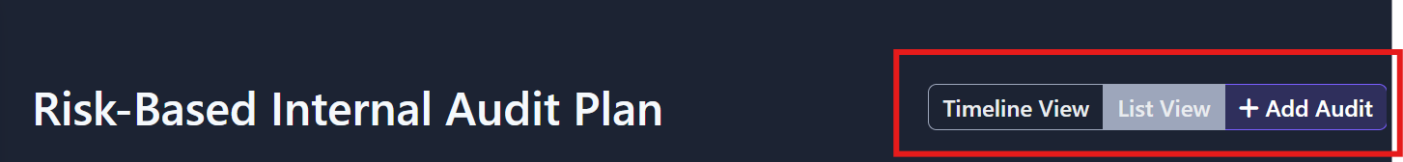

**Impact:**

* Diminishes overall visual coherence and professionalism.
* Increases maintenance complexity for developers.

**Recommendation:**

* Standardize the button design across all components
* Use a consistent background colour

**Benefit:**

* Improves usability by establishing predictable interaction patterns.
* Strengthens brand identity through unified visual elements.

**2.Redundant “Get Priority Suggestion”:**

**Observation:**  
The **"Get Priority Suggestions"** button is visually styled as active and clickable but fails to produce any result or feedback upon user interaction. There is no loading indicator, modal, or error message displayed..

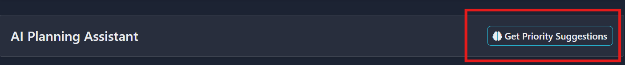

**Impact:**

* Users are left uncertain whether their action was registered or failed silently.
* Breaks the expected workflow for prioritizing risks using AI, one of the platform’s key features.
* Reduces trust in the AI assistance promise of the tool.

**Recommendation:**

* Ensure the button is connected to a functioning backend or AI service endpoint.
* If the feature is still in development, **disable the button** and display a tooltip like *“Feature under development”*.
* Provide feedback on interaction (e.g., spinner, toast notification, or modal), even if temporarily unavailable.

**UI/UX Evaluation**

**Audit Reports Screen**

**1. “Use Enhanced Report Builder” Access Denied Despite Visibility:**

**Observation:**  
The **“Use Enhanced Report Builder”** button is fully styled and visible within the report generation modal. Upon clicking, the user receives an **access denied** message or is blocked from proceeding, despite no prior indication of restricted access.

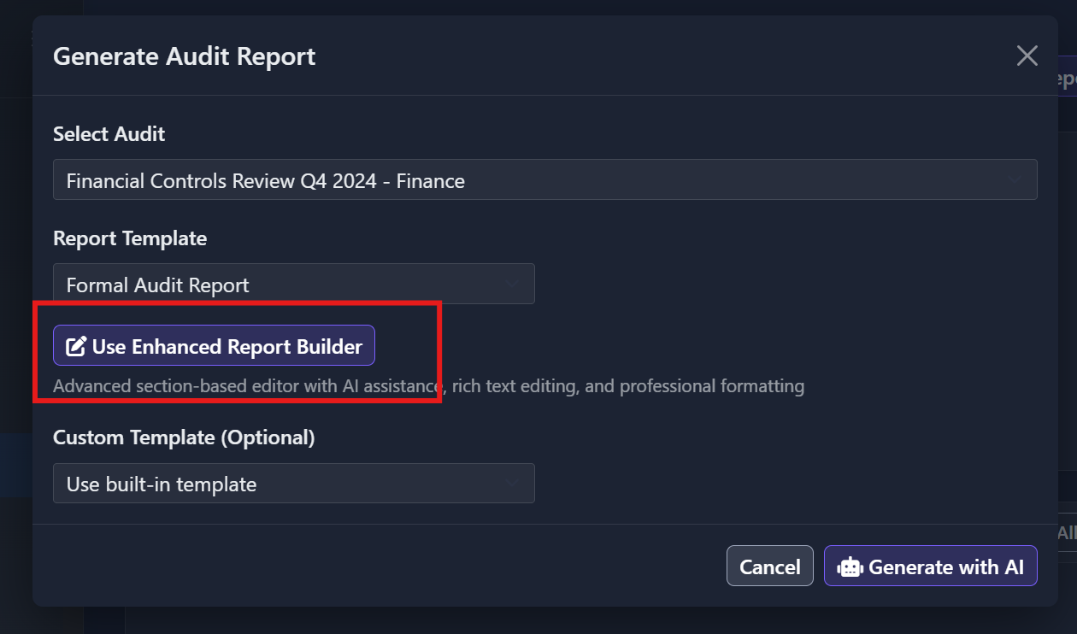

**Impact:**

* Causes confusion and frustration — users expect a visible button to be usable.
* Interrupts workflow during report generation, especially when selecting preferred editing options.
* Creates a perception of broken or poorly gated functionality.

**Recommendation:**

* Conditionally render the button only for users with the correct permissions. If access is restricted:
* Use a disabled state with a lock icon and tooltip (e.g., “Enhanced Report Builder available to Admins only”).
* Or display an upsell-style banner or tooltip indicating why access is restricted and how to enable it.
* If the button must remain visible, validate access before click and redirect to an informative screen rather than showing a hard error.

**Benefit:**

* Prevents negative user experiences tied to unclear access rules.
* Increases transparency and control over premium or role-based features.
* Encourages user upgrade or access request when framed positively.
  + - 1. **“Use Enhanced Report Builder” Access Denied Despite Visibility:**

**Observation:**  
The “Generate with AI” button in the report generation modal appears fully interactive and styled, but clicking it does not trigger any action or feedback. There’s no loading indicator, error message, or change in UI state after clicking.

**Impact:**

* Creates uncertainty — users are unsure if the action was registered or failed silently.
* Interrupts a critical part of the audit workflow, especially for users relying on AI to accelerate report creation.
* Undermines confidence in the AI capabilities promised by the platform.

**Recommendation:**

* **Implement immediate visual feedback** upon click (e.g., loading spinner, disabled state, progress bar).
* Ensure backend connectivity for AI generation is functioning and catch any service errors.
* If AI generation is gated by other form fields, display validation errors or tooltips explaining the unmet requirements.

**Benefit:**

* Restores trust in the AI report generation feature by providing clear, immediate response to user actions.
* Enhances user experience by removing confusion around whether a task has been initiated.
* Reinforces perception of a polished, reliable, and intelligent platform.

**UI/UX Evaluation**

**Smart Action Plan Settings Screen**

**1. “Smart Action Plan Settings – Success Notification Banner-** **Low Visibility of Success Notification:**

**Observation:**  
The success toast message **“Action plan settings updated successfully!”** appears at the top of the screen but has **very low contrast** between the green text and dark background. The message blends into the UI, especially on lower brightness displays, making it hard to read or even notice.

**Impact:**

* Users may **miss important feedback** confirming their action was successful.
* Can lead to **repetitive clicking or reconfiguration**, assuming the update didn’t register.
* Reduces confidence in system responsiveness and visual clarity.

**Recommendation:**

* Improve background-to-text contrast to **meet accessibility minimums** (WCAG 2.1: at least 4.5:1 for normal text).
* Suggested UI improvements:
* Use a **brighter desaturated green** background (e.g., #2E7D32 or similar).
* Apply **white or light-colored text** for contrast.
* Add subtle **padding**, **rounded corners**, and a **drop-shadow or border** to visually separate the banner from the background.
* Optionally include an icon animation or timed disappearance for clarity.

**Benefit:**

* Ensures that users **immediately recognize** confirmation feedback.
* Supports **accessible and inclusive design standards** for all visual environments.
* Improves overall **interaction clarity** and user satisfaction with system response behaviours.

**2** **Add Info (i) Icons for Each Checkbox Option:**

To improve clarity and help users understand what each setting means:

**Action:** Add a small **“i” icon** next to each checkbox with a tooltip or modal.

##### Example:

* **Require file attachment for "Closed" status**  
  🛈 (i icon tooltip: “Ensure a file is uploaded when an action is marked as closed.”)
* **Auto-CC line managers on action updates**  
  🛈 (tooltip: “Automatically CC line managers when actions are updated.”)
* **Auto-CC audit leads on responses**  
  🛈 (tooltip: “Automatically CC audit leads when responses are made to the actions.”)

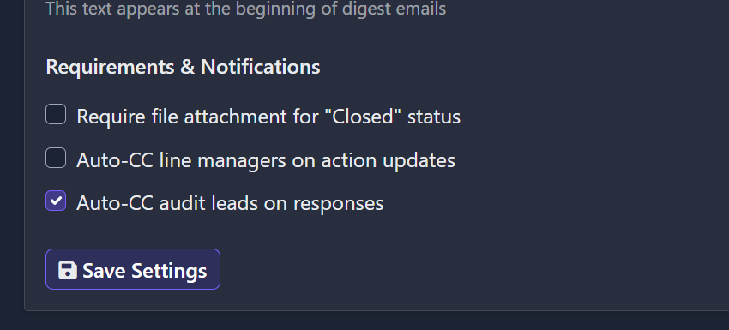

**3.** **Add Confirmation Modal on “Save Settings”:**

* To ensure users don’t accidentally save unintended configurations:
* **Action:** Trigger a confirmation modal when **Save Settings** is clicked.
* **Benefit:** This lets users **review their choices** before final submission and avoids misconfigurations.

**UI/UX Evaluation**

**Smart Action Plan Analytics Screen**

**1. Low Visibility of Success Notification Banner in Smart Action Plan Settings:**

**Observation:**  
Text inside the "Action Plan Trends" cards is not clearly visible due to low contrast. Labels and values are faint and hard to read.

**Impact:**

* Poor readability affects quick scanning and user understanding. Fails accessibility standards and may confuse users.

**Recommendation:**

* Increase contrast between text and background. Use bolder, darker text styles to improve clarity.

**UI/UX Evaluation**

**AI Settings Screen**

**1. Low contrast of dropdown heading text:**

**Observation:**  
The heading “Strictness Levels” within the expanded dropdown has insufficient contrast between the text color and the background. It appears faded or disabled due to its light lavender shade on a slightly lighter background, making it hard to distinguish—especially for users with visual impairments or those in low-light environments.

**Impact:**

* **Accessibility Barrier:** Users with low vision or color vision deficiencies may not be able to read or notice the heading properly.
* **Perceived Inactivity:** It visually resembles a disabled element, causing confusion about whether the section is clickable or already inactive.
* **Violation of WCAG:** Fails to meet WCAG 2.1 **Success Criterion 1.4.3 (Contrast Minimum)** – requiring a contrast ratio of at least **4.5:1** for normal text.
* **Poor Hierarchy:** Headings are meant to establish visual hierarchy, but this heading blends into the background, diminishing clarity

**Recommendation:**

* Increase the contrast between the text and background by:
* **Darkening the text color** (e.g., using a darker shade like #4B4B4B or #2C2C2C)
* OR **lightening the background**
* Use a minimum contrast ratio of **4.5:1** for normal text, or **3:1** if it’s a bold font and at least 18.66px.
* Consider using standard heading semantics (<h3> or <h4>) with accessible contrast to reinforce hierarchy and assist screen readers.

**UI/UX Evaluation**

**AI Pattern Learning Dashboard Screen**

**1. Redundant "Initialize Pattern Analysis" Button:**

**Observation:**  
The "Initialize Pattern Analysis" button appears visually active and styled with hover effects, but it does not trigger any action or provide feedback when clicked.

**Impact:**

* Users may assume the feature is broken or unfinished, leading to frustration.
* It disrupts workflow continuity, especially for users expecting AI learning to begin immediately.
* Reduces user confidence in the reliability of AI-related features on the platform.

**Recommendation:**

* Ensure the button is linked to a functioning backend or trigger a modal explaining why it cannot proceed (e.g., “Complete at least X audits to begin pattern analysis”).
* If the feature is incomplete or data-dependent, use a disabled state with a tooltip explaining why it’s unavailable.
* Optionally, trigger a toast notification or loader to confirm action is being processed (even if backend delay exists).

**Benefit:**

* Prevents confusion and clarifies the system’s readiness state.
* Provides users with immediate feedback and actionable next steps, improving system transparency and trust.
* Reinforces a sense of responsiveness and professionalism in the interface.